1.Raspberry Pi platform-------whistle
- Preparation
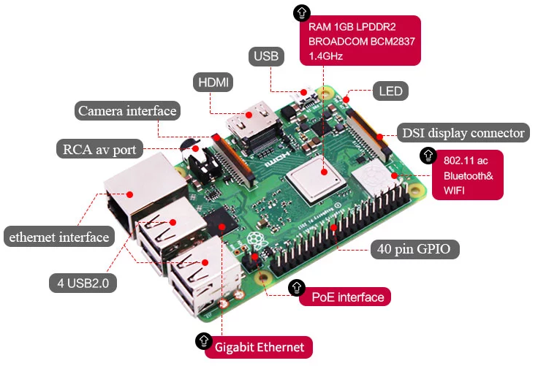
1-1 Raspberry Pi board
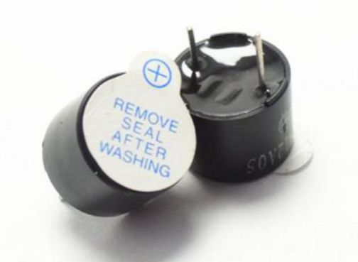
1-2 Buzzer module
- Purpose of Experimental
After running the whistle executable in the Raspberry Pi system, the car will whistle.
- Principle of experimental
Buzzers are divided into two types: "active buzzers" and "passive buzzers". Active means that they possess a multi-vibrator inside. It only needs to provide the working voltage externally, it can emit a fixed frequency sound. Passive means that there is no internal oscillation source, and an external drive circuit is required to provide a certain frequency of the drive signal.
In this experiment, we will use active buzzer.

- Experimental Steps
4-1 About the schematic
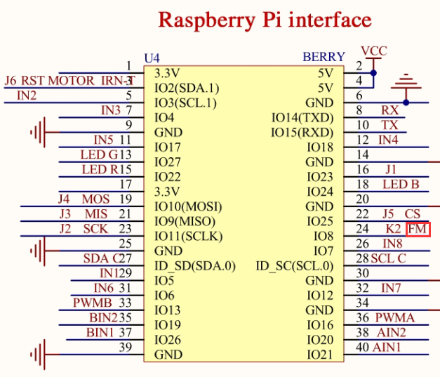
4-1 Raspberry Pi board
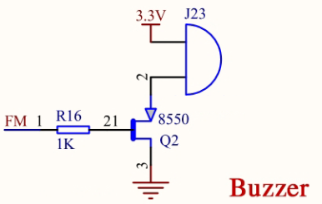
4-2 Buzzer module

According to the circuit schematic diagram, positive electrode of the positive buzzer is connected to 3.3V, the negative electrode is connected to 8550 triode, the collector of the triode is connected to GND, the collector of the triode is connected in series with a 1K resistor, and the other end of the resistor is connected to the physical pin 24 of the Raspberry Pi.
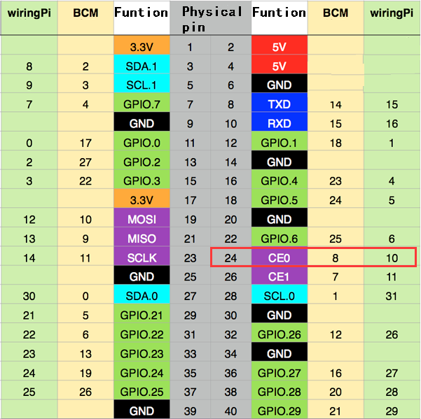
4-3 Raspberry Pi 40 pins comparison table

4-2 According to the circuit schematic:
FM-----24(Physical pin)----- 10(wiringPi)
(Note: We use the wiringPi library to write code.)

4-3 About the code
(1) We need to compile this file in the Raspberry Pi system. (Note: we need to add -lwiringPi to the library file.)
We need to input:gcc whistle.c -o whistle -lwiringPi
(2)We need to run the compiled executable file in the Raspberry Pi system.We need to input: ./whistle
(3)We can input: ctrl+c to stop this process, which mean is send a signal to the linux kernel to terminate the current process, but the state of the relevant pin is uncertain at this time, we also need to run a script to initialize all pins.
(Note:The initpin.sh script file is included in the SmartCar directory.)
You need to input: chmod 777 initpin.sh
./initpin.sh
As shown in the figure below.

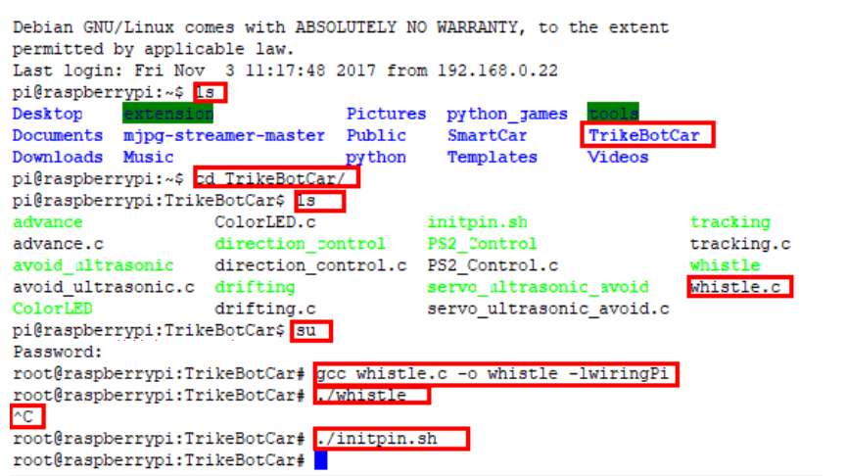
After completing the above steps, the experiment is over.

